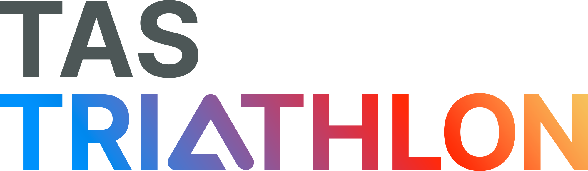

BOARD CHARTER

VERSION 1.0
OCTOBER 2022

TABLE OF CONTENTS

1. OVERVIEW………………………………………………………………………………PAGE 1

2. THE BOARD……………………………………………………………………………..PAGE 1

2.1 Triathlon Tasmania Board Obligations………………………………………PAGE 1
2.2 Triathlon Tasmania Board Rights……………………………………..……..PAGE 1
2.2 Skills Matrix………………………………………………………………….....PAGE 2
2.3 Onboarding……………………………………………………………………..PAGE 2
2.4 Board Meetings……………………………………………………………...…PAGE 3
2.5 Governing Style………………………………………………………...………PAGE 3

3. CHAIRPERSON/PRESIDENT ROLE……………………………………………….…PAGE 3

4. DIRECTOR ROLE…………………………………………………………..……………PAGE 3

5. COMMUNICATION……………………………………………………………………….PAGE 4

Overview
The Triathlon Tasmania Board (TTAS) plays an important role in the successful delivery of triathlon and multisport experiences in Tasmania, although it has delegated operational responsibility to Triathlon Australia (TA), under an agreement dated 1st April 2022 (Agreement).
The TTAS Board’s role is predominantly to provide oversight and advice to the TA Board and staff, including recommendations during the development of TA’s strategic plan. The Chairperson/President of the TTAS Board will represent the TTAS Board in meetings with the TA Board as scheduled under the Agreement. The TTAS Board is responsible for the ongoing relationships between TA and the members; promoting partnership, collaboration and participation in the delivery of the National strategic plan.
The TTAS Board can also be supported by Committees, if it chooses to create them from time to time.

THE Board

TTAS Board Obligations
The TTAS Board must:
    - Execute governance duties and comply with applicable legal obligations, such as:
      - complying with the Tasmanian Associations Act;
      - review and accept (subject to satisfactory review) the financial reports as provided by TA;
      - complying with and maintaining its constitution; and
      - holding the TTAS annual general meeting, with assistance from TA staff.
    - Through the TTAS Chairperson/President (who is the TTAS Board representative at the TA AGM and a member of the Presidents Committee):
      - be responsible for exercising and discharging its rights as a member under the TA constitution, including to elect the members of the TA board;
      - contribute to the development of the national strategic plan (the Plan) at meetings held by TA, including initiatives and services;
      - monitor TA’s performance of the services with regard to the performance targets as set out in the Agreement, and provide feedback and support with the goal of helping TA better provide the Services and meet the Performance Targets;
      - contribute toward the development of the annual national budget, and the Performance Targets, with specific input into the investment in key strategic projects; and
      - execute any necessary documentation for grant or funding applications sought by TA in accordance with the Plan.

TTAS Board Rights
The TTAS Board may, where its directors are able to do so, and in collaboration with TA staff:
    - support the execution of the Plan for the promotion, advancement and growth of Triathlon Australia-wide;
    - represent Triathlon with peak bodies in the pursuit of our purpose (including governments and other stakeholders);
    - represent the interests of its members internally and externally to help ensure Triathlon and multisport events are conducted in the best interests of the participants; and
    - attend and participate in formal events such as medal presentations or awards ceremonies.

Skills Matrix
The desired skills, qualifications and attributes for Directors shall be determined each year.

The recommended selection criteria include:

commitment to the organisation’s objects, policies, rules and values;

knowledge of triathlon/multisport and Australian sport in general;

demonstrated ability to understand a wide scope of community issues, including requirements and objectives of governing and charitable bodies;

management and administration skills, preferably with knowledge of Not-for-Profit compliance in the areas of corporate governance and directors’ duties and responsibilities;

excellent presentation, communications and advocacy skills in order to articulate the vision and objects of the organisation;

ability to demonstrate major achievement or contributions in previous roles (either in a professional capacity or in sport);

ability to work and communicate effectively within the group and with external parties. A candidate must not at any time act in a manner prejudicial to, or contrary to the interests or objects of the organisation;

commitment to the role and have the ability to devote sufficient time and energy to the position, including a preparedness to engage in professional development as required;

Directors may have specific skills in government, governance, strategy, commerce, finance, marketing, law or business generally or such other skills which complement the Board composition and the organisations strategic priorities but need not necessarily have experience in or exposure to sport.

Onboarding
All new Directors will be briefed by the Chairperson/President and will receive a copy (either electronically or by hard copy) of the following items:

this charter;

TA organisational chart;

TTAS Constitution;

TA’s Strategic plan;

the Associations Act (or a link to it);

Information on how to apply for a Directors ID;

Applicable Sports Australia Governance and Sport Integrity Australia courses;

directors and officers insurance policy;

access to the most recent board minutes;

other relevant documents as appropriate or requested.

Board Meetings

The TTAS Board shall meet as often as necessary to discharge its duties and or in accordance with its Constitution. Meetings can be conducted either face to face or virtually.

The TA CEO (or delegate) may attend a TTAS Board meeting at any time as agreed between the TTAS Board and TA and may nominate representatives from within TA to support, assist or inform the TTAS Board.

The State Services Lead will attend Board Meetings and will report to the TA CEO (or delegate), following each meeting of the TTAS Board. If the State Services Lead is unable to attend the TTAS Board Meeting, a suitable TA representative will attend in their place.

TA will meet with the TTAS Board in line with the meeting frequency outlined in the Agreement.

Governing Style
The Board will govern with an emphasis on:

anticipating and planning for change;

objectivity;

strategic leadership;

demonstration of and shaping of the TA culture through the behavioural framework; Unity, Accountability, Courage, Enjoyment, Inclusivity;

managing and minimising risk;

clear distinction of its and TA’s role;

collective decision making rather than individual;

focus on the future direction of TA; and

being proactive rather than reactive.

CHAIRPERSON/PRESIDENT ROLE

The Chairperson/President shall preside over TTAS Board meetings. If the Chairperson/President is not available to chair a Board meeting, the Board must elect a Director present to do so. The role is summarised below.

DIRECTOR ROLE
Directors of TTAS Board:

should be committed to ethical, business like and lawful conduct including proper use of authority and appropriate decorum when acting as Directors;

must always act in the interests of TA/ TTAS and the members;

must be respectful of each other and TA staff;

must appropriately manage/mitigate or avoid conflicts of interest;

must not attempt to exercise individual authority over TA or make decisions outside of their designated scope of authority;

should not publicly voice any negative comments or individual opinions relating to the CEO, staff, fellow Directors or any TA matter or issue;

should only speak to the media as requested by the CEO or the Chairperson/President;

should adhere to and support the Chairperson/President in an effort to govern effectively and should act with Board solidarity around Board decisions and agreed actions; and

should respect the confidentiality of sensitive issues or business items under negotiation or discussion

COMMUNICATION
The TTAS Board will communicate and work with TA using the following framework as a guide.

HIGH

Collaborate
GM Sport Services & State Services Lead work with Board
Maintain Confidence
GM Sport Services & State Services Lead work with State President

INFLUENCE
Extent to which TTAS Board buy-in is NEEDED to move forward

Keep Informed
State Services Lead reports to Board
Monitor and Respond
State Services Lead reports to Board if required

HIGH
LOW

IMPACT
Extent to which a decision will impact TTAS Board and members

END

This Charter was approved by the TTAS Board on 1st August 2023

Document Control Information

Policy Information

Policy Contact and Author | Alex Anasson – GM Sport Services | Approving Body: | Implementation Steering Committee
Status: | Published | Review period: | Annual
Policy No and Version: | 1.0 | Next review date: | October 2023
Effective Date: | 20/10/2022 | Document Location: | Implementation Steering Committee Teams Channel
Responsible Officer: | Alex Anasson – GM Sport Services | Policy System Manager: | Lori Organ

Document History

Version | Date Approved | Author | Description of revision | Internal Distribution
 |  |  |  | Date | Recipient/s
1.0 | 15th September 2022 | Alex Anasson | Creation
1.1 |  |  | Revision
1.2 |  |  | Revision

