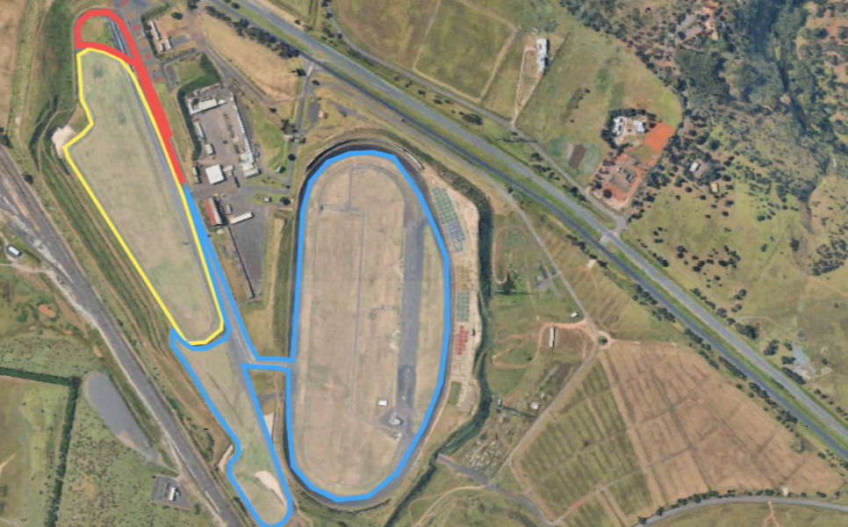
DASH
Run 1 = 1.5km loop (yellow circuit – heading north & anti clockwise)
Ride = 10.2km (3 laps x blue circuit – heading south & anti clockwise)
Run 2 = 800m out/back (red circuit – heading north & clockwise)

